 **Introduction to DevOps**

**BCS/BS 6A**

Github assignment

# GROUP MEMBERS:

MUHAMMAD SHAYAN SHAHID (2212325)

MUHAMMAD ASHAD BAIG (2212115)

Creating a GitHub Repository

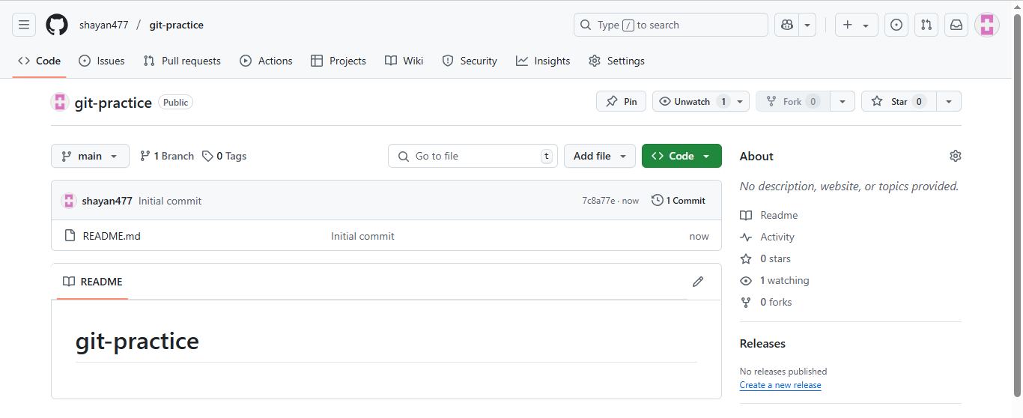

Cloning the Repository

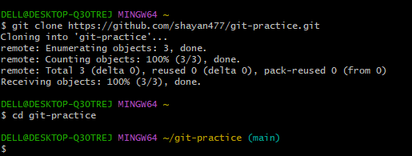

Making Changes Locally

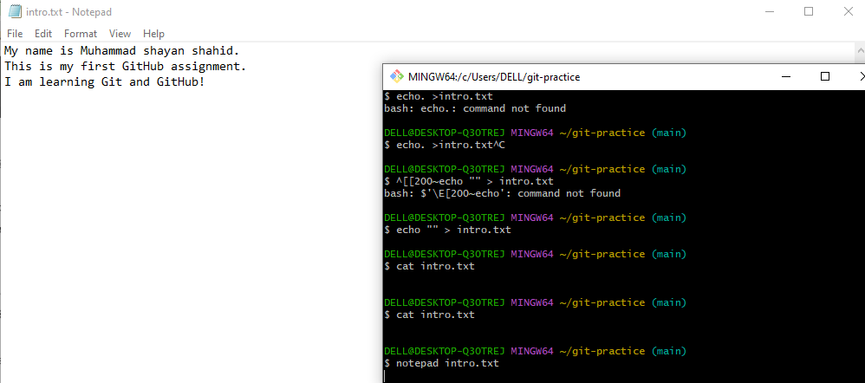

Stage and Commit Changes

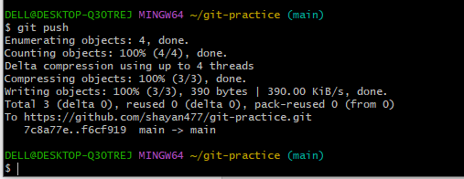

Push to GitHub

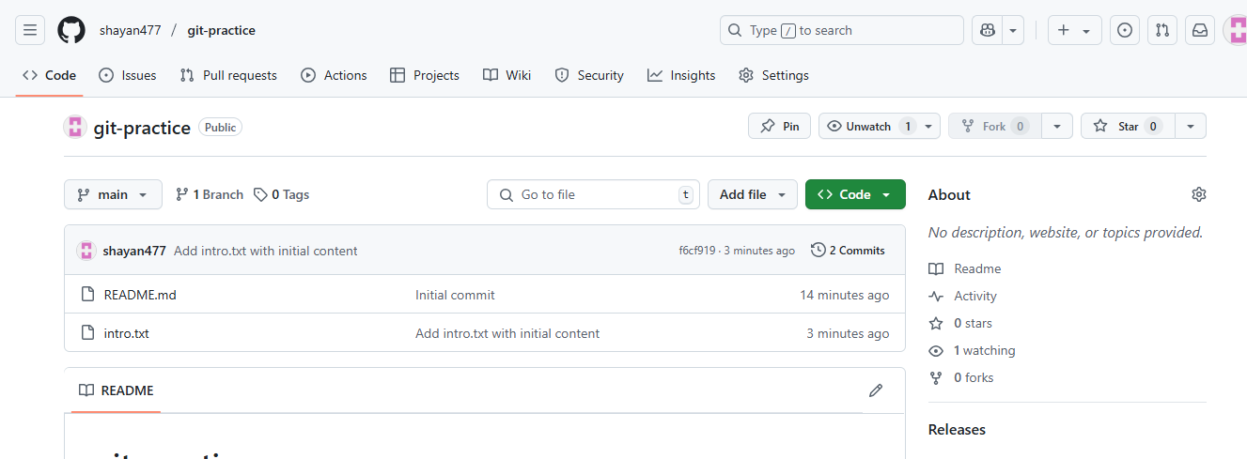

Create a Branch and Additional Changes

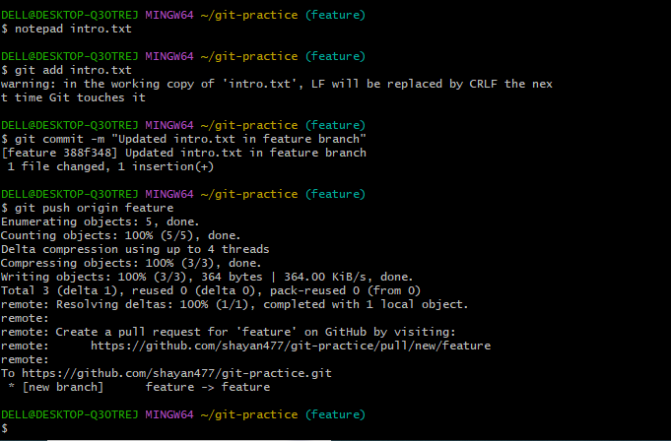

Create and Merge a Pull Request

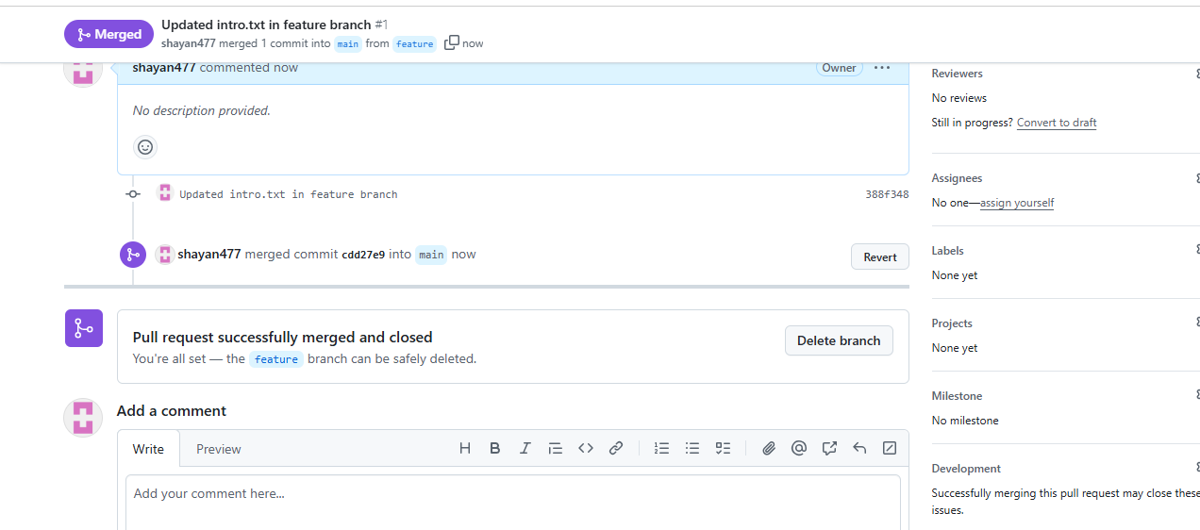

Sync Local Repository

